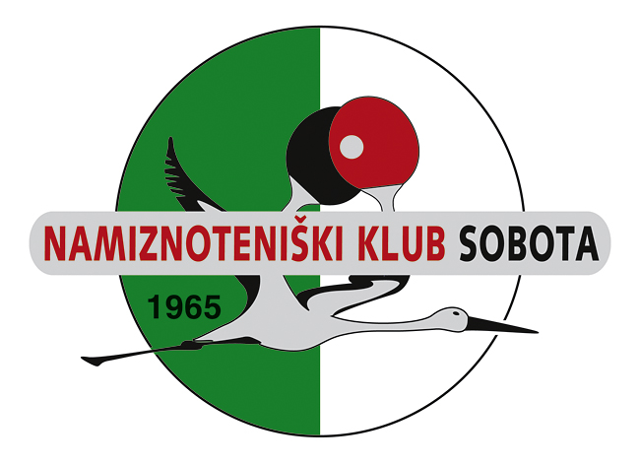 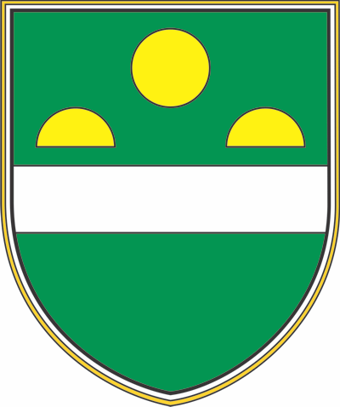 Mestna občina Murska Sobota

INVITATION FOR APPLICATION AND PROPOSITIONS FOR
8th international tournament In memory to Mirko Unger
Sunday, 3th September 2023

ORGANIZER: NTK Sobota, Mladinska ulica 3, 9000 Murska Sobota

PLACE: Sports hall at the Primary school III, Trstenjakova 73, 9000 Murska Sobota

TIME & SCEDULE: Sunday 3th September 2023 at 09:30 am

DISCIPLINES/AGE CATEGORIES:

A) born 1984 and before at 09:30 F) women born 1974 and before at 09:30
B) 40 – 49 at 09:30
C) 50 – 59 at 09:30 G) women 50 and older at 09:30
D) 60 - 69
E) 70 and older at 09:30

H) ABSOLUTE MEN at 15:00 I) ABSOLUTE WOMEN at 15:00

All players may play in 2 single age category ( one veterans at 09:30 and absolute at 15:00 )
PLAYING SYSTEM:

Individual competition ( age categories A-I ) will be played in groups. Each group will have 3-4 players and each player will play with every member of the group. In the pre-competition group are pleayed on two or three won sets up to 11. The first and the second place winners continue to compete on KO system until the final victory. The third and the fourth player in the group play a consolation tournament with falling out to the end ( K. O. system ). All the games in the final and consolation groups are played on three won sets up to 11. Category H and I will play K.O. system. Whoever does not qualify for the round of 16 will continue in the consolation round.

APPLICATIONS: send to : ntksobota@gmail.com

DEADLINE FOR ENTRIES: Thursday 31th August 2023

ENTRY FEE: ( 15 EUR )

LUNCH : Čevapčiči and Lušt tomatoes ( between 13:30 do 14:30 )

BALLS: TIBHAR***

PRIZES: Cups for the all finalists and big medals for players in semi-finals and for best in consolations tournaments small medals.

We look forward to seeing you in Murska Sobota !!! Organizer : NTK Sobota

